**Social and cognitive predictors of success in the transition to school**

**1. Correlation and Multiple Regression**

Introduction

Beginning school brings significant social difficulties, like making and keeping companions, consenting to rules and schedules, adapting to dismissal and the danger of one or the other scholar or social disappointment. This undertaking benefits from a current investigation of a socially assorted example of 270 youngsters (135 fellowship matches) seen at age 4. Different mental capacities add to making this variation an effective one; a few important formative ideas that exchange is theory of mind (ToM), executive function and verbal ability. Youngsters' social change will be surveyed by means of organized interviews with kids, educators and guardians, as well as through recorded perceptions of kids playing with their companions in free-play and in both co-usable and cutthroat play; cognitive abilities (for example verbal capacity, social awareness, arranging and working memory) will be evaluated by means of separately regulated errands and manikin games (Hughes, Claire, 2016).

The data collection (i.e., abridged dataset) involves survey data collected from around 250. For this study, used variables are Verbal IQ, Dweck emotion, Dweck ability, Simple Theory of Mind, Complex Theory of Mind, Executive functions, and demographic information (that is Age and Gender).

The main objective of this study is to investigate their statistical analysis on these factors to learn their relationship and anticipate their results.

Results

The correlation analysis was identifying the relationship between several variables that is Verbal IQ, Dweck emotion, Dweck ability, Simple Theory of Mind (sToM), etc (Table 1), and Table 2 shows the descriptive statistics (Mean and Standard Deviations).

The executive function (EF) variable shows that the significantly positive (level of correlation is weak and moderate) correlation with Age (r(N=293) = 0.336, p = 0.000), sToM (r(294) = 0.443, p = 0.000), aToM (r(294) = 0.367, p = 0.000), and BVPS (r(291) = 0.451, p = 0.000). However, the significantly negative and weak correlation with Dweck ability (r(292) = -0.142, p = 0.015). On the other hand, the significantly strong positive correlation identifies between the sToM and aToM that is (r(294) = 0.676, p = 0.000). Also, a significantly positive strong correlation was observed between aToM and BVPS (r(289) = 0.516, p = 0.001).

Now, in the next section is to investigate the possible predictive relationships by using the Hierarchical Multiple Regression Model, the outcome variable is aToM and the predictor variables are in the data is that executive function (EF, Model-2), simple theory of mind (sToM, Model-1), verbal IQ (BPVS, Model-3). The reason for choosing these three independent variables is all of them are statistically significant and highly correlated with outcome variable.

Based on the result (Table 2, ANOVA), the overall level of significance of the Model-1, Model-2, and Model-3 is statistically significant that is (F(1,289) = 242.555, p-value = 0.000), (F(1,288) = 123.323, p-value = 0.000), and (F(1,287) = 309.826, p-value = 0.000), respectively. Additionally, BPVS and sToM both are statistically significant in model-3. However, the executive function variable (EF) was not significant when entered in the model 2 and 3. Thus, the change in the R-square of Model-1, Model-2 and Model-3 is 0.456, 0.05, and 0.030, respectively (see Table 3 (iii)).

**2. Mediation/Moderation**

Introduction

Theory of mind depicts the capacity to participate in context taking, surmise mental states, and foresee goals, conduct, and activities in others. Theory of mind execution is related with essential mental and socioemotional abilities, including verbal capacity (responsive and expressive language), execution function (inhibitory control and working memory), and feeling information. In addition, expressive language also served as an arbitrator to the point where children with limited expressive language were unable to work on the theory of mind, regardless of the initial theory of mind implementation (Brock, Kim, et al., 2019). To better comprehend how well these factors combine, researchers looked at the consistency of EF in pre-schoolers and discovered that their EF scores improved with time and, surprisingly, their linguistic ability predicted changes in EF (Fuhs, M. W., & Day, J. D., 2011). To examine the effect or relationship bewteen these varibales age, BPVS, and interaction term of age and verbal ability with the outcome varibale is executive function.

Result

A regression model was conducted to observed the relationship between EF (as an outcome), verbal ability (as a predictor), age (as the moderator), and age*verbal ability (as interaction term). After run the regression, the result displayed in table 4 which implies that the significance of overall model is statistically significant because of p-value is less than the level of significance i.e., 0.000 < 0.05, (F(3,286) = 32.391, p-value = 0.000). Also, the moderator and the interaction term is not statistically significant.

Conclusion

The variables are age, sToM and aToM, Executive function (EF) and verbal ability (BPVS) were statistically significantly correlated with each other. sToM and aToM has highly correlated among all the variables. The age is the only factor that is statistically significant predictor of EF, however, no effect of interaction term and moderator to EF. These findings support the study of (Fuhs, M. W., & Day, J. D., 2011), which found that while verbal ability predicts EF in preschool children, cognitive ability alone is insufficient to explain variation in theory of mind.

# **References**

Brock, Kim, et al., L. L. (2019). The development of theory of mind: predictors and moderators of improvement in kindergarten. *Early Child Development and Care*, 1914-1924.

Fuhs, M. W., & Day, J. D. (2011). Verbal Ability and Executive Functioning Development in Preschoolers at Head Start. *Developmental Psychology*, 404-416.

Hughes, Claire. (2016). Social and cognitive predictors of success in the transition to school. *ESRC*.

**SPSS Output**

**Table 1: Correlation**

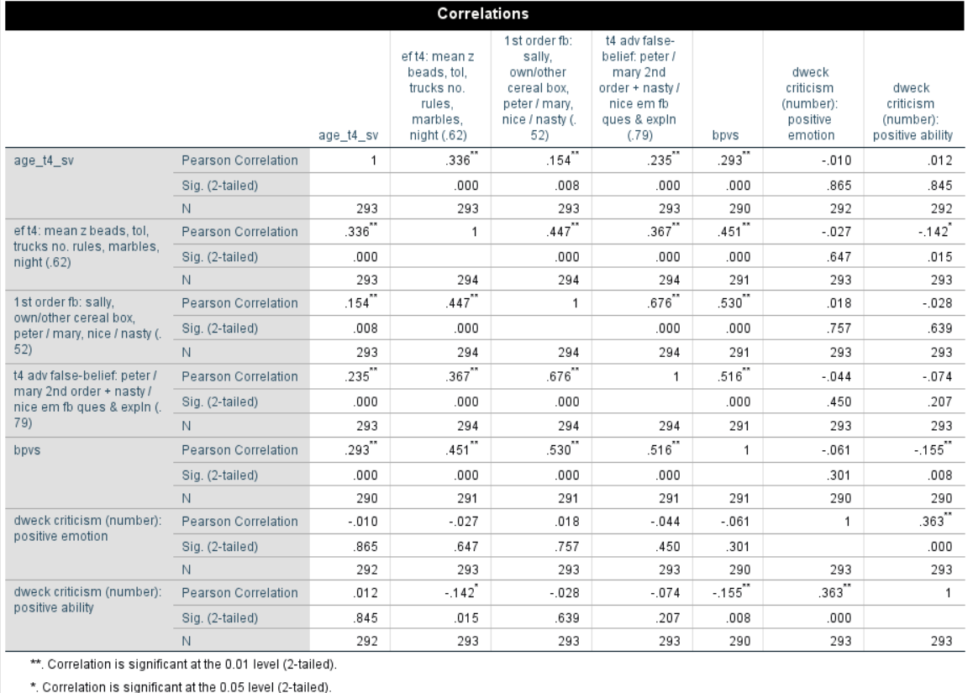

Table 2: Mean and Standard Deviations

|  |  |  |  |
| --- | --- | --- | --- |
| **Descriptive Statistics** | | | |
|  | Mean | Std. Deviation | N |
| age_t4_sv | 5.9883 | .42730 | 293 |
| ef t4: mean z beads, tol, trucks no. rules, marbles, night (.62) | -.0034 | .62686 | 294 |
| 1st order fb: sally, own/other cereal box, peter / mary, nice / nasty (.52) | 5.2415 | 1.45449 | 294 |
| t4 adv false-belief: peter / mary 2nd order + nasty / nice em fb ques & expln (.79) | 4.2959 | 2.55803 | 294 |
| bpvs | 54.8007 | 13.97367 | 291 |
| dweck criticism (number): positive emotion | .9488 | .76801 | 293 |
| dweck criticism (number): positive ability | .5870 | .78302 | 293 |

**Table 3: Hierarchical Multiple Regression**

1. Coefficients Table

|  |  |  |  |  |  |  |
| --- | --- | --- | --- | --- | --- | --- |
| **Coefficientsa** | | | | | | |
| Model | | Unstandardized Coefficients | | Standardized Coefficients | t | Sig. |
| B | Std. Error | Beta |
| 1 | (Constant) | -1.913 | .415 |  | -4.613 | .000 |
| 1st order fb: sally, own/other cereal box, peter / mary, nice / nasty (.52) | 1.188 | .076 | .676 | 15.574 | .000 |
| 2 | (Constant) | -1.584 | .460 |  | -3.444 | .001 |
| 1st order fb: sally, own/other cereal box, peter / mary, nice / nasty (.52) | 1.125 | .085 | .640 | 13.211 | .000 |
| ef t4: mean z beads, tol, trucks no. rules, marbles, night (.62) | .321 | .196 | .079 | 1.637 | .103 |
| 3 | (Constant) | -2.918 | .552 |  | -5.290 | .000 |
| 1st order fb: sally, own/other cereal box, peter / mary, nice / nasty (.52) | .971 | .091 | .552 | 10.687 | .000 |
| ef t4: mean z beads, tol, trucks no. rules, marbles, night (.62) | .090 | .199 | .022 | .454 | .650 |
| bpvs | .039 | .009 | .214 | 4.137 | .000 |
| a. Dependent Variable: t4 adv false-belief: peter / mary 2nd order + nasty / nice em fb ques & expln (.79) | | | | | | |

1. ANOVA Table

|  |  |  |  |  |  |  |
| --- | --- | --- | --- | --- | --- | --- |
| **ANOVAa** | | | | | | |
| Model | | Sum of Squares | df | Mean Square | F | Sig. |
| 1 | Regression | 862.678 | 1 | 862.678 | 242.555 | .000b |
| Residual | 1027.865 | 289 | 3.557 |  |  |
| Total | 1890.543 | 290 |  |  |  |
| 2 | Regression | 872.158 | 2 | 436.079 | 123.323 | .000c |
| Residual | 1018.385 | 288 | 3.536 |  |  |
| Total | 1890.543 | 290 |  |  |  |
| 3 | Regression | 929.479 | 3 | 309.826 | 92.523 | .000d |
| Residual | 961.064 | 287 | 3.349 |  |  |
| Total | 1890.543 | 290 |  |  |  |
| a. Dependent Variable: t4 adv false-belief: peter / mary 2nd order + nasty / nice em fb ques & expln (.79) | | | | | | |
| b. Predictors: (Constant), 1st order fb: sally, own/other cereal box, peter / mary, nice / nasty (.52) | | | | | | |
| c. Predictors: (Constant), 1st order fb: sally, own/other cereal box, peter / mary, nice / nasty (.52), ef t4: mean z beads, tol, trucks no. rules, marbles, night (.62) | | | | | | |
| d. Predictors: (Constant), 1st order fb: sally, own/other cereal box, peter / mary, nice / nasty (.52), ef t4: mean z beads, tol, trucks no. rules, marbles, night (.62), bpvs | | | | | | |

1. Model Summary Table

|  |  |  |  |  |  |  |  |  |  |  |
| --- | --- | --- | --- | --- | --- | --- | --- | --- | --- | --- |
| **Model Summaryd** | | | | | | | | | | |
| Model | R | R Square | Adjusted R Square | Std. Error of the Estimate | Change Statistics | | | | |
| R Square Change | F Change | df1 | df2 | Sig. F Change |
| 1 | .676a | .456 | .454 | 1.88590 | .456 | 242.555 | 1 | 289 | .000 |
| 2 | .679b | .461 | .458 | 1.88044 | .005 | 2.681 | 1 | 288 | .103 |
| 3 | .701c | .492 | .486 | 1.82993 | .030 | 17.117 | 1 | 287 | .000 |
| a. Predictors: (Constant), 1st order fb: sally, own/other cereal box, peter / mary, nice / nasty (.52) | | | | | | | | | | |
| b. Predictors: (Constant), 1st order fb: sally, own/other cereal box, peter / mary, nice / nasty (.52), ef t4: mean z beads, tol, trucks no. rules, marbles, night (.62) | | | | | | | | | | |
| c. Predictors: (Constant), 1st order fb: sally, own/other cereal box, peter / mary, nice / nasty (.52), ef t4: mean z beads, tol, trucks no. rules, marbles, night (.62), bpvs | | | | | | | | | | |
| d. Dependent Variable: t4 adv false-belief: peter / mary 2nd order + nasty / nice em fb ques & expln (.79) | | | | | | | | | | |

Figure 1: Normal Distribution Plot

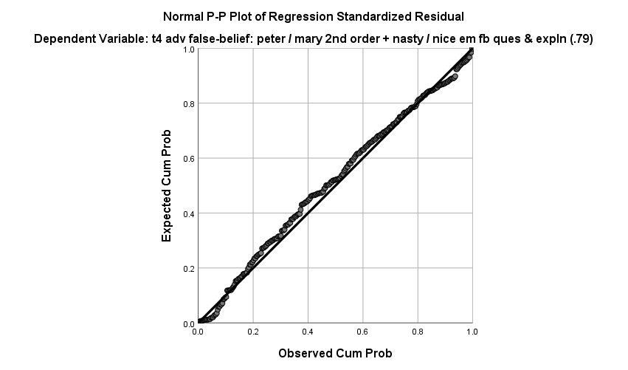

**Table 4: Moderation (Interaction Term)**

(i) Coefficients

|  |  |  |  |  |  |  |
| --- | --- | --- | --- | --- | --- | --- |
| **Coefficientsa** | | | | | | |
| Model | | Unstandardized Coefficients | | Standardized Coefficients | t | Sig. |
| B | Std. Error | Beta |
| 1 | (Constant) | -4.599 | 1.610 |  | -2.856 | .005 |
| age_t4_sv | .607 | .268 | .413 | 2.259 | .025 |
| bpvs | .050 | .030 | 1.112 | 1.676 | .095 |
| AgexVerbal | -.005 | .005 | -.803 | -1.094 | .275 |
| a. Dependent Variable: ef t4: mean z beads, tol, trucks no. rules, marbles, night (.62) | | | | | | |

(ii) ANOVA

|  |  |  |  |  |  |  |
| --- | --- | --- | --- | --- | --- | --- |
| **ANOVAa** | | | | | | |
| Model | | Sum of Squares | df | Mean Square | F | Sig. |
| 1 | Regression | 29.082 | 3 | 9.694 | 32.391 | .000b |
| Residual | 85.593 | 286 | .299 |  |  |
| Total | 114.675 | 289 |  |  |  |
| a. Dependent Variable: ef t4: mean z beads, tol, trucks no. rules, marbles, night (.62) | | | | | | |
| b. Predictors: (Constant), AgexVerbal, age_t4_sv, bpvs | | | | | | |

(iii) Model Summary

|  |  |  |  |  |  |  |  |  |  |
| --- | --- | --- | --- | --- | --- | --- | --- | --- | --- |
| **Model Summary** | | | | | | | | | |
| Model | R | R Square | Adjusted R Square | Std. Error of the Estimate | Change Statistics | | | | |
| R Square Change | F Change | df1 | df2 | Sig. F Change |
| 1 | .504a | .254 | .246 | .54706 | .254 | 32.391 | 3 | 286 | .000 |
| a. Predictors: (Constant), AgexVerbal, age_t4_sv, bpvs | | | | | | | | | |

**Screening Data**

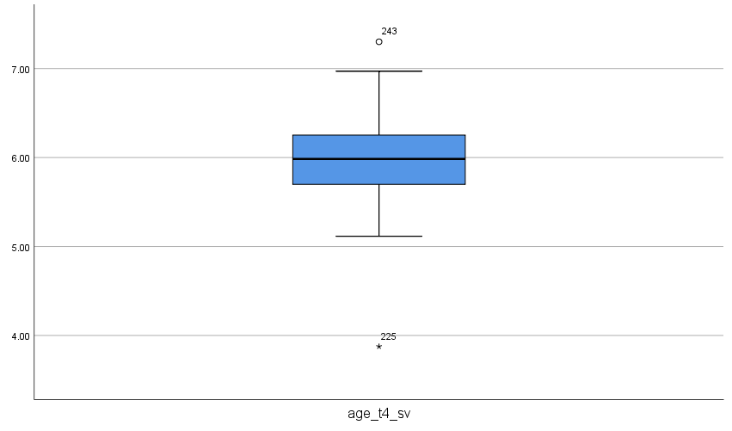

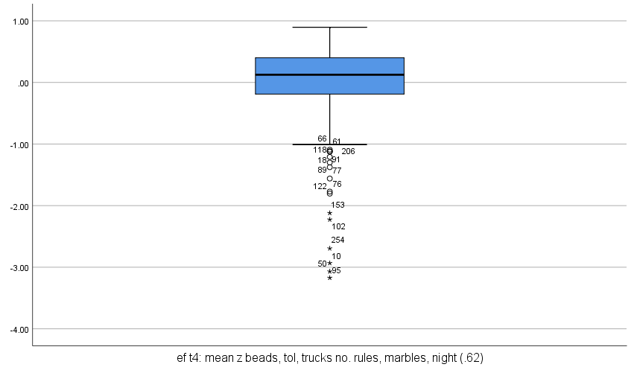

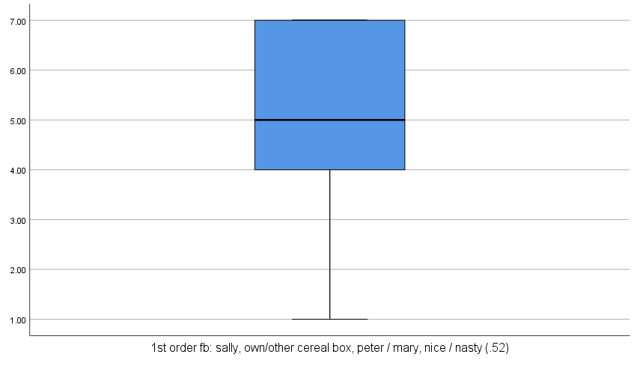

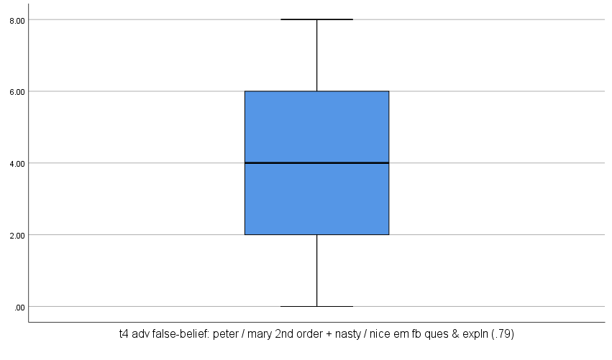

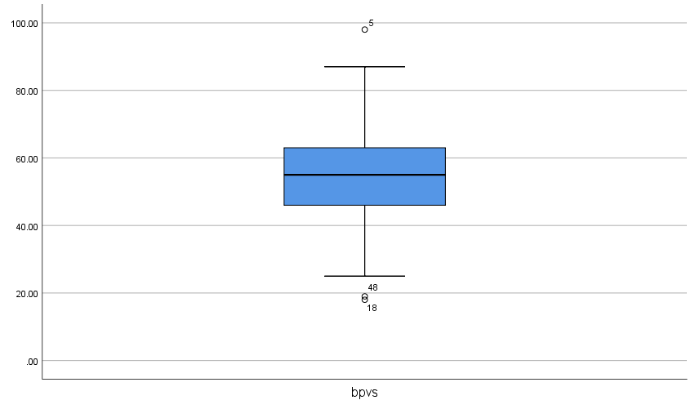

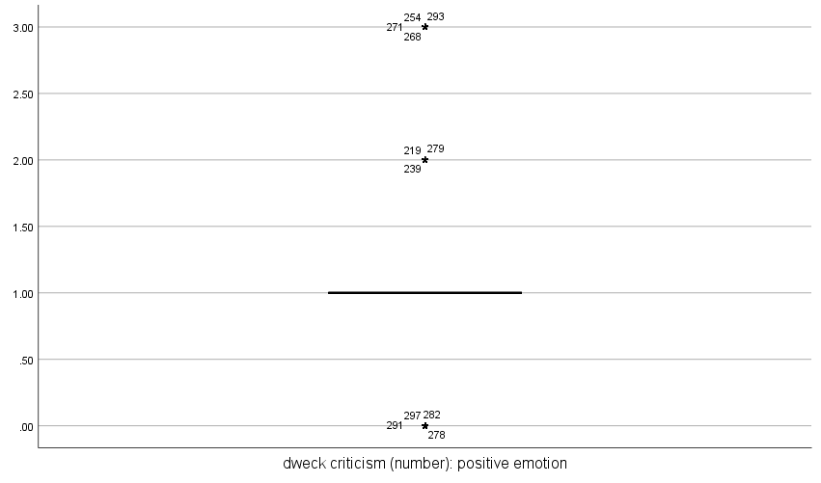

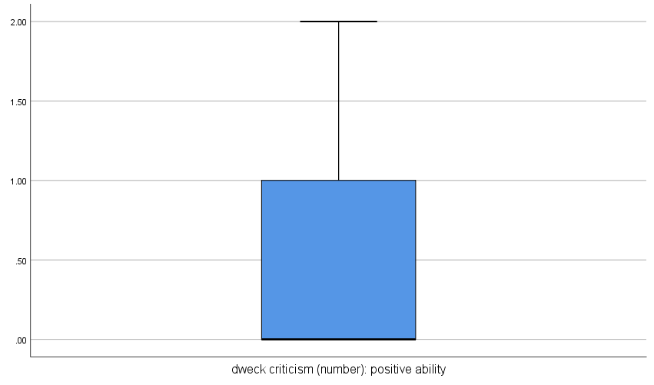

Histograms indicating non-parametric data

